User Manual

TalkBox App Final Version

Group 3

Authors: Andrew Maywapersaud

Chandler Cabrera Seo Hyun Jeong James Kong

Contents

|  |  |
| --- | --- |
| Preface | Page 2 |
| Configuring your TalkBox | Page 3 |
| 1.1 File Menu | Page 4 |
| 1.2 Recording Audio | Page 4 |
| 1.3 Selecting an Audio set | Page 5 |
| 1.4 Audio file searching | Page 5 |
| 1.5 Creating a custom audio set | Page 6 |
| 1.6 TalkBox simulator | Page 7 |

# Preface

## Requirements

* + - Computer with Windows 10
    - Microphone (USB or 3.5mm jack)

First, let’s start with some definitions that will be commonly referenced throughout this manual.

|  |  |
| --- | --- |
| Audio Clip | Short snippers of audio that the application plays back upon pressing the respective audio button |
| Audio Set | A set/group/bundle of audio clips loaded into buttons with respective icons representing them, all usually with a common theme per set |
| TalkBox Configurator | The initial screen of the application that allows you to view default audio sets, create your own custom audio sets, record custom audio, import existing sets and more |
| TalkBox Simulator | A simulation of an actual TalkBox device, it launches from the configuration with the buttons and audio sets configured |

# Introduction to TalkBox

The TalkBox associates sound files and icons to buttons; when a button is pressed, the sound file plays. There are two parts to this application: the TalkBox Configurator and the TalkBox Simulator.

The former allows you to record your own audio clips, aggregate audio clips into an audio set (for immediate use or to save it for later), or upload your own audio sets from your computer. It additionally allows you to add icons to each button for visual clarity and appeal.

The latter allows you to simulate your physical TalkBox by using the audio sets you selected in the TalkBox Configurator. This will help you fine tune your audio sets before you upload them to an actual TalkBox.

# Configuring your TalkBox

1.5

1.3

1.4

1.2

1.1

TalkBox Configurator

This is what you see when you open the TalkBox Configurator. Refer back to this later when prompted

Each subsection of instructions is labelled on this image for your reference.

To begin, proceed to 1.1 – The File Menu

## 1.1 The File Menu

## The File Menu has three options: [Export Data], [Import Data], [Log] and [Exit].

[Export Data], when pressed, lets the user export their current TalkBox data set into a .tbc file for future use.

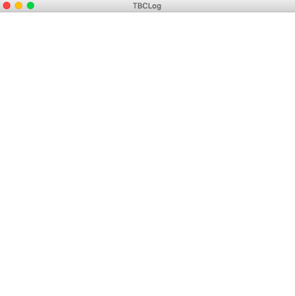[Import Data], uses this aforementioned .tbc file and loads in all of the data such as audio sets.

[Log], when pressed, opens a log of actions that you, the user, have currently taken in this session of using the configurator.

[Exit], being true to it’s name, simply exits the application.

* 1. 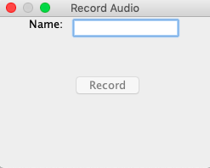 Recording Audio

Begin by clicking on [Record New Sound].

This new window should appear. First, type in a name of the sound clip in the Name field. When you’re ready, click [Record].

The [Record] button will change to a [Stop] button. Now, speak clearly into the microphone. When you are finished, click [Stop].

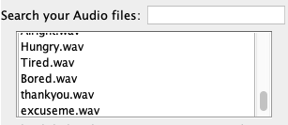Your recording should now alphabetically appear list of audio files underneath the (Search your audio files) field. If you want to re-record it, remove it by selecting it and pressing [remove], and then repeating the previous step.

Continue recording as many clips as you would like. However, this just adds them to your audio file directory. If you would like to use this audio files to create your own audio set from scratch, then proceed to the section about creating custom sets.

# Selecting an Audio set

To see the audio sets that are already loaded, press on the drop-down menu and select an audio set. The configurator always starts with one pre-loaded audio set.

These audio sets contained pre-recorded audio clips. Select the pre-loaded audio set to see all of the audio clips that it contains.

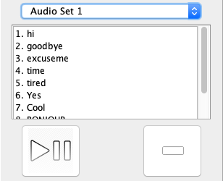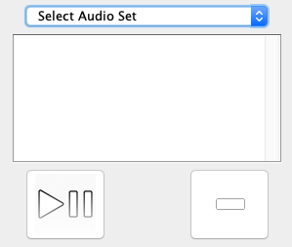A number-ordered list will appear showing the names of each sound clip inside the selected audio set. To preview what each will sound like, click on one of these audio clips and pressing the [Play/Pause] button. When clicked, it will audibly play the selected sound file and will stop the audio when clicked again or when the user plays another audio file.

Remove

Play/Pause

To delete an audio file from a set, click the [remove] button which will remove that audio file from that particular audio set.

1.4 Audio File Searching

In order to search for audio files in your audio file directory, there is a search prompt where the user can type in a string which will dynamically parse the list for any strings that match.

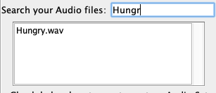All preset audio files are in this list alongside any that are recorded by the user. It is also alphabetically ordered for ease of parsing.

# 1.5 Creating a custom audio set

# First, check the box below (Check below box to create custom Audio Set). This will enable the use of the buttons [Add as button], [Clear Selections] and [Create into Audio Set].

# Select the audio clip you would like to add from the list mentioned in 1.4 which contains all of the pre-loaded audio files alongside all of the user-recorded audio files. In order to add it to your own custom audio set, press [Add as button].

# 

Clear Selections

Checkbox

Add as button

Create into Audio Set

# Another prompt will now pop-up asking the user to add an icon to their button.

# 

# The user must now browse their directory for an appropriate and supported image file for their selected audio file in order to create their button. They can delete their selected icon if they choose incorrectly. If they are certain they want to choose that icon, they simply click [Add Selected Icon] and the button will be loaded into the audio set they are in the process of creating.

# The current audio files that have been created into buttons can be viewed in the text area on the right hand side of the configurator.

# At any point during this process, the user can choose to press [Clear Selections] to delete all existing buttons they have created and start fresh.

# The user must also enter an appropriate name for the audio set.

# If they have decided that what they have created is sufficient, they can finalize their creation by clicking [Create into Audio Set] which will now make the audio set show up in the dropdown list shown in 1.3.

# This audio set will also now be shown in the simulator should they decide to run it which brings us to the final topic of the simulator.

# 

# 1.6 TalkBox Simulator

This is the TalkBox Simulator. Using it is pretty straight forward; to play the audio clip you want, press on its corresponding button.

This is made even clearer by the implementation of icons where the user visually see which buttons apply to which audio files instead of having to read them each time.

The [Swap] dropdown browses through the audio sets that were configured in the previous steps such as adding your own custom audio sets to the configurator.

When you are done using the TalkBox Simulator, press File > Exit.

Swap dropdown